Handling Rejection Errors in iConnect - Checklist
WSCs should be monitoring their Dashboard daily for notifications. If a consumer’s service authorization is in Rejected status, you will need to review the error message to correct the issue.

The following is a checklist for reviewing the Error Message and a table of FMMIS error codes, what they mean, and how to correct the error.

Accessing error message in rejected authorization
☐ | Click on Auths Tab in consumer’s record.
☐ | Do not click on the + sign of the rejected authorization (If you need to expand to make sure you are dealing with the rejected authorization, you can click on the + and then close it by clicking on the – sign).
☐ | Click on single row of the rejected authorization, this will launch all the service authorizations for the provider for the date range of the service authorization.  - There will be two tabs on the left-hand side of the screen, an Authorization tab and an AuthService tab:  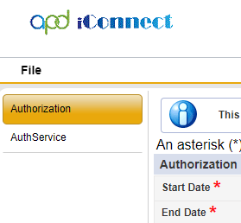
☐ | Click on AuthService tab:  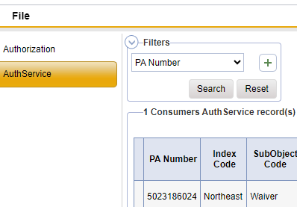
☐ | Click on service that has the rejected authorization, this will launch the service authorization. There will be two tabs on the left-hand side of the screen, an AuthService tab and an Error Message tab:  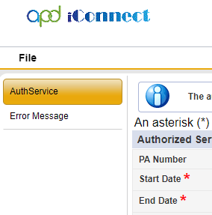
☐ | Click on Error Message tab:
☐ | Review the Error Message for reason FLMMIS has rejected the authorization.
☐ | Refer to the FMMIS Service Authorization Error Rejection list with explanations to determine how to resolve the rejection.

FMMIS Service Authorization Error Rejections
Error Code | Error Message | Error Explanation | How to Correct
06 | Recipient not Eligible | Consumer lost Medicaid eligibility before service authorization (SA) sent to FMMIS. | Check consumer's eligibility on the Eligibility Tab and address the issues for eligibility to be restored.
10 | Duplicate PA | There is another SA in FMMIS that overlaps with the newly created SA. | Check the AUTH tab to see which PA/authorization needs to be addressed.
75 | Sum of claims greater | SA allocation is lower than what the provider has billed on the PA in FMMIS. | Check claims in APD claims report or provider to see if the provider has over billed or increase the allocation on SA to at least the amount of the paid claims.
79 | no description given | SA has been cancelled in iConnect, but not in FMMIS due to the fact that the provider has billed against the PA, | Review claims in the APD Paid Claims report.  Address the issue with the provider of whether or not the provider was authorized to bill.  Depending on outcome provider will need to void billing OR WSC will need to correct total # of units field and resend to FMMIS.
L3 | Line item not found | SA balance in FMMIS is zero. | If funds were added to the SA, the provider needs to void the last paid claim.  Then the SA needs to be resent to FMMIS to update the PA balance.
L4 | Invalid authorized amount | Allocation on the SA is zero. | Enter the correct allocation and resend to FMMIS for PA number.
L5 | Invalid unit rate | Unit rate on SA is zero. | Enter the correct rate and resend.

Please refer to the WSC iConnect eLearning Library for more information. Please contact your Regional Trainer if you have questions.

